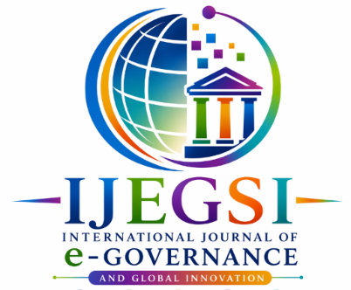

International Journal of e-Governance and Scientific Innovation
Open Access Journal
www.IJEGSI.com

Copyright Transfer Form
This document must be signed by the corresponding author and submitted to editor@ijegsi.org or info@ijegsi.org

Paper ID:
Paper Title:
Email address:
Contact number:

Copyright Transfer and Declaration for the IJEGSI
I hereby transfer the Copyright of the paper entitled:

I acknowledge and agree that the Editor-in-Chief may, at their discretion, transfer the copyright of the published work to the publisher. I further understand that if plagiarism or any form of academic misconduct is discovered in the manuscript, the Editor-in-Chief reserves the right to retract or reject the paper, even after its publication in a previous issue. In such circumstances, no refund will be issued.
The author(s) retain all proprietary rights, including patent rights and the right to use the article, in whole or in part, in their future scholarly or professional works, including lectures, press releases, and textbook reviews. Any republication of the article, whether in whole or in part, in another periodical, journal, or reprint publication by a third party requires prior written permission from the IJEGSI Editor-in-Chief.
I hereby declare that the material presented in this paper constitutes our original work and does not contain any material reproduced from other copyrighted sources without proper authorization. Where material from other sources has been incorporated, it has been clearly identified through appropriate quotation marks and/or proper attribution. All sources have been duly acknowledged and accurately cited in the relevant sections of the paper.
The paper, in its final version enclosed herewith, is original and has not been substantially published elsewhere. Neither this manuscript nor any substantially similar paper has been submitted or is currently under consideration for publication by any other journal or publisher.

Date: (DD/MM/YYYY) Place:

Corresponding author’s name:
Signature:

